HS-QR31 thermal Label&Receipt kiosk printer

Features:
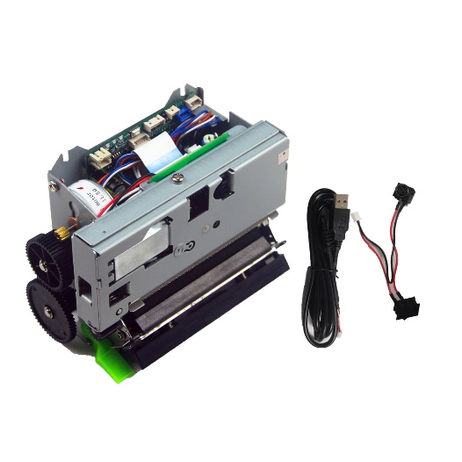
- High Printing Speed up to 250mm/second;
- Compatible with EPSON M-T532;
- Support Raspberry Pi 2
- Support Windows, Linux,Android SDK
- Factory/Manufacture with engineer team, able to do OEM&ODM
- With cutter, mechanism, control board; With bracket optional
- SUPORT USB+RS232/usb+ttl Interface
- Support max 80mm—20mm Label paper and 80MM Receipt papert
- Holding down the Feed button, power on selftest.
- Support Blackmarker sensorfunctions

Applications:
KIOSK & vending machine, queuing machine, Promotion coupon printing machine
Parking system, Gas station filling machine, Game machine & vote machine
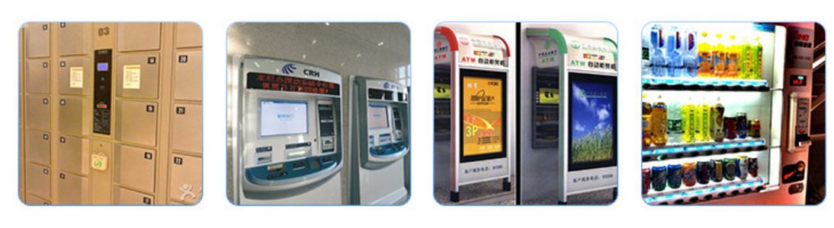

Specifications:
Printing Method | Thermal
Dots/line | 640 dots/line
Resolution | 203DPI
Paper type | Label sticker& thermal paper roll
Printing Width(mm) | 72mm
Paper Width(mm) | 20-80mm
Paper Thickness(μm) | 56-150
Feed Resolution(mm) | 0.125
Interface | USB+RS232/USB+TTL
W x D x H(mm) | 127*100*62mm
Weight(g)
Head temperature detection | Thermistor
Paper detection | Transmission photoelectricity switch
Black mark detection | Reflecting photoelectricity pipe
Platen position detection | Light touch swith
Operation voltage (V) | 24±10%
Logical voltage(V) | 5±0.25
Formfeeding motor voltage(V) | 24±10%
Auto cutting motor voltage(V) | 24±10%
Detection voltage (V) | 5±0.25
Abrasion resistance | 100 km
Auto cutting frequency | 1 million times
Operating temperature(°C) | 0 to 50 (no condensation)
Operating humidity(RH) | 10% to 80% (no condensation)
Storage temperature(°C) | -25 to 70 (no condensation)
Storage humidity(RH) | 5% to 95% (no condensation)

